Data can be imported from any database, and also from many other software programs. In this training module, we will be importing records from Microsoft Excel into FileMaker Pro. In Lesson 3, there are links for three Excel files on the web site, so please download these files into the same folder as your database.

We will first import records from the Microsoft Excel file named “customers.xls” into the existing table “customers”, and then we will be importing records from the Microsoft Excel file named “payments.xls” into the existing table “payments”. Our third Microsoft Excel file named “clients.xls” will be imported into the database as a new table called “clients”.

## Directions on importing records from Microsoft Excel

1. Switch to Layout mode for Customers table
2. File Menu
3. Import Records
4. File

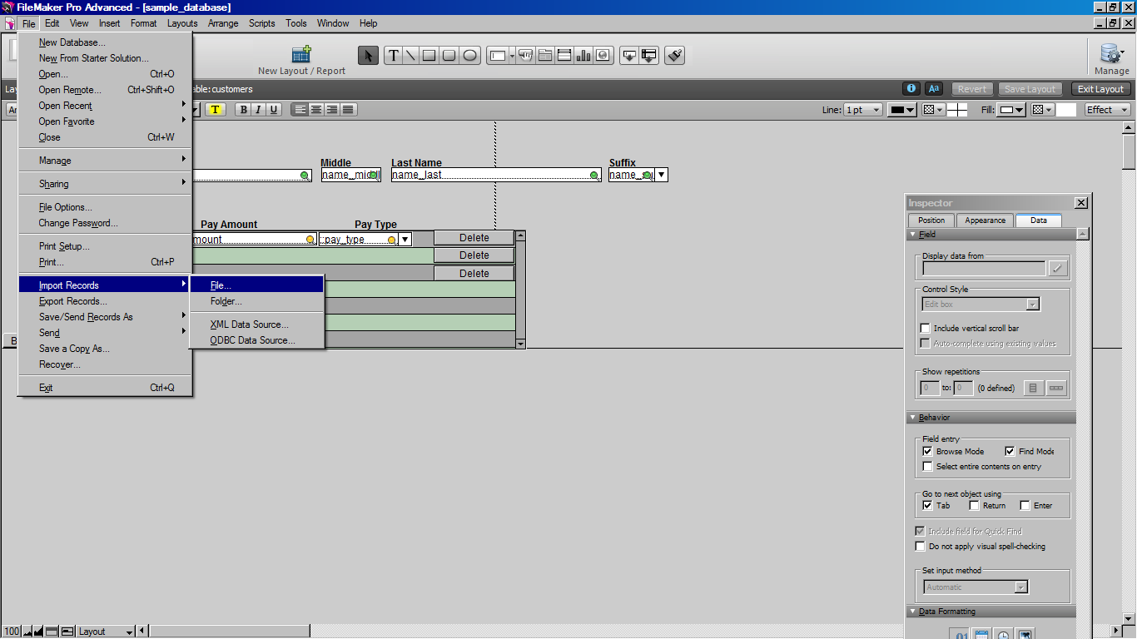

1. 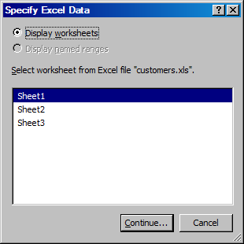Locate the **customers.xls** Excel file
2. Ensure **Sheet1** is selected
3. Click Continue

1. Using the vertical arrow icon, drag the Target Fields to match the Source Fields.

NOTE: you can also click the green right arrow if the field should not be imported.

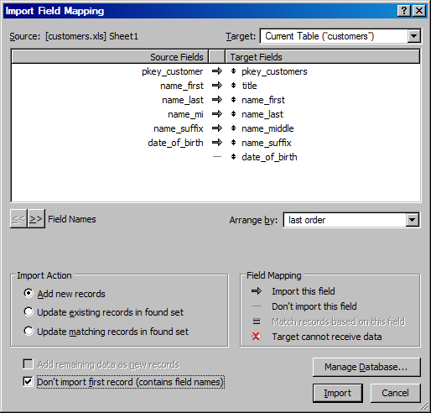

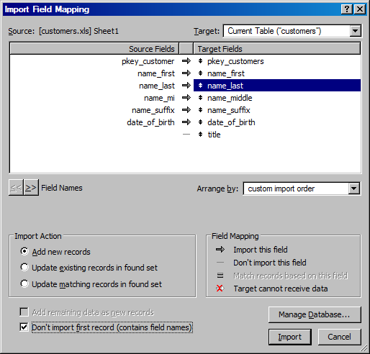

1. Scroll through the records to ensure fields are mapped correctly.

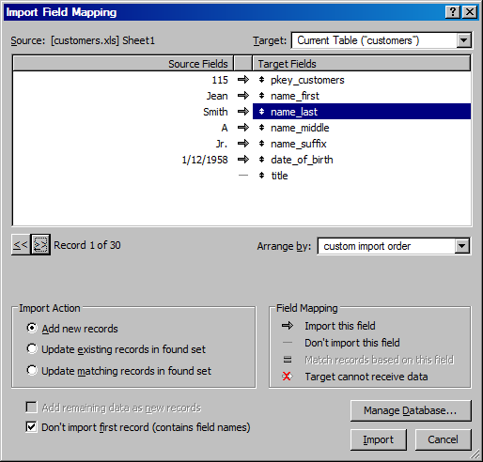

1. Don’t import first record (if Excel file has Row 1 headings)
2. Click Import button
3. Click Perform auto-enter options while importing.
4. Click Import button

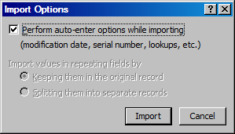

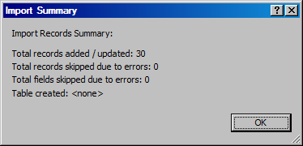

1. If you open Browse mode, you will now notice that 30 customer records have been added to the customers table in the FileMaker Pro database.

## Importing records from Microsoft Excel into the Payments table

1. Change to the Layout Mode for the Payments table.

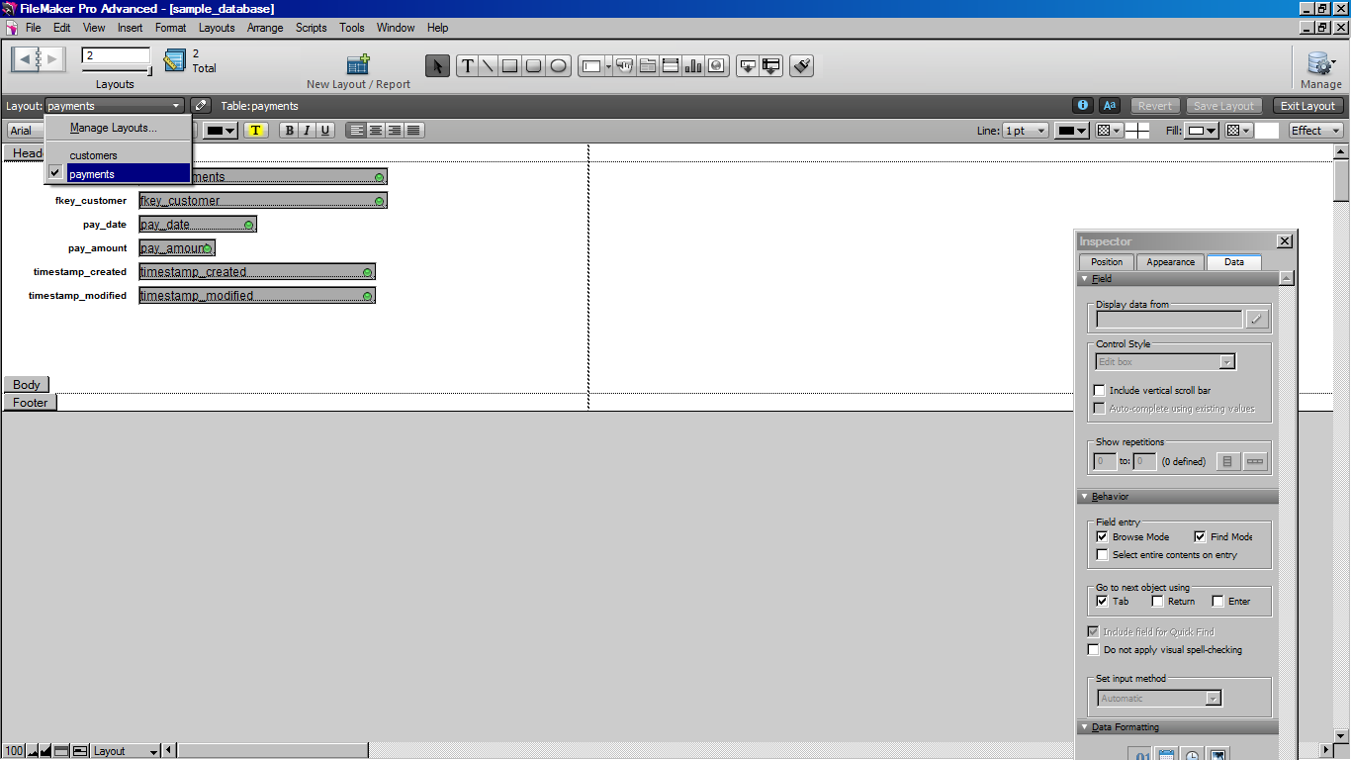

1. File Menu
2. Import Records
3. File
4. Locate the **payments.xls** Excel file
5. Ensure **Sheet1** is selected
6. Click Continue
7. Using the vertical arrow icon, drag the Target Fields to match the Source Fields.
8. Scroll through the records to ensure fields are mapped correctly.

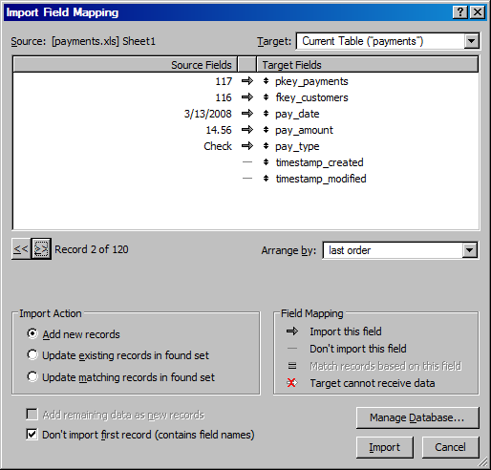

1. Click “Don’t import first record” (if Excel file has Row 1 headings)
2. Click Import button
3. Click Perform auto-enter options while importing.
4. Click Import button
5. If you open Browse mode, you will now notice that new payment records have been added to the payments table in the FileMaker Pro database.

## Importing records from Microsoft Excel into a new table

1. File Menu
2. Import Records
3. File
4. Locate the **contacts.xls** Excel file
5. Ensure **Sheet1** is selected

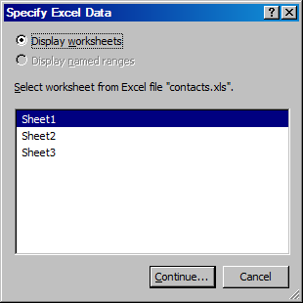

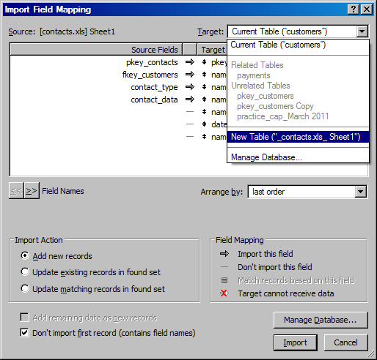

1. Click Continue
2. Change Target to New Table
3. A new table with 62 records is now created.

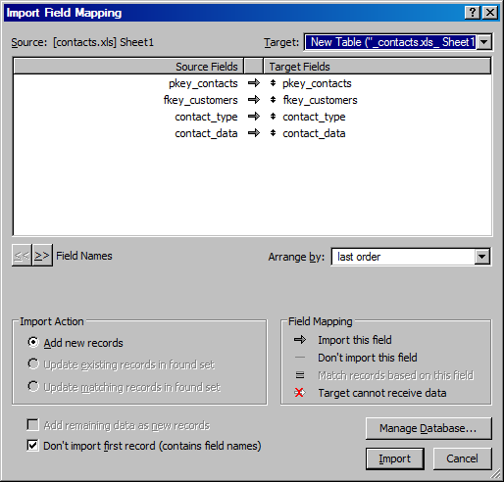

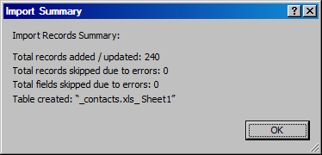

1. File/Manage Database/Relationships
2. Drag pkey_customers from customers table to fkey_customers in contacts table.

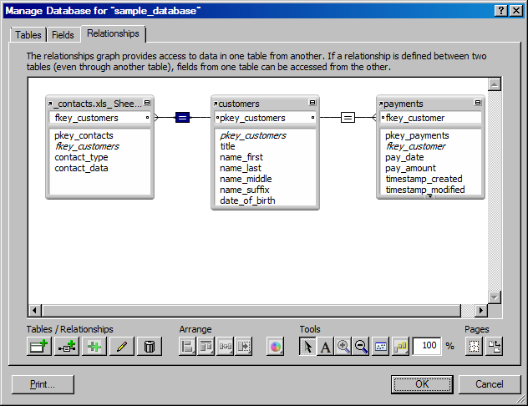

1. Change to layout mode in customers table
2. Click portal button, drag a rectangle to right of payments portal
3. Select contacts.xls

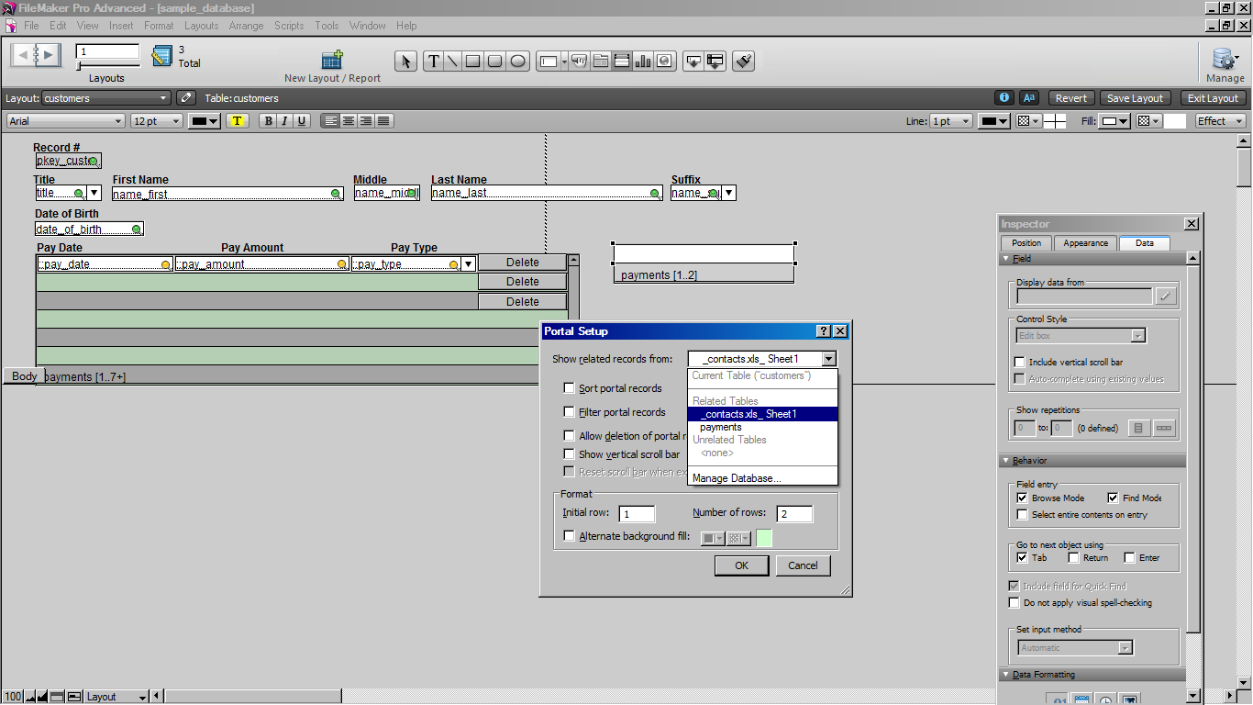

1. Show vertical scroll bar
2. Alternate background (if desired)

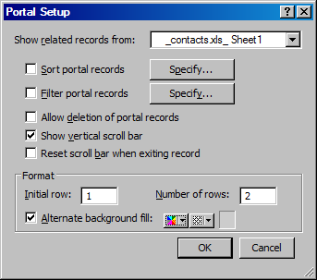

1. In the Add Fields to Portal dialog box, double click to select **contact_type** and **contact_data**.
2. Click OK.
3. Increase width of contacts portal (if needed)

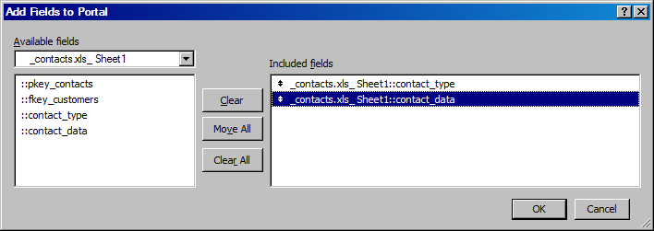

1. Change to Browse Mode (click Yes to Save)
   * Notice the newly imported contact information.